**Azure Fundamentals (AZ-900)**

**AZURE VOCABULARY**

1. **Azure Data Center :**

* **Physical facility**
* **Hosting for** group of networked **servers**
* Own **power**, **cooling** & **networking** infrastructure

1. **REGION**
   * **Geographical area** on the Planet
   * One but usually more datacentres connected with low-latency network (< 2 milliseconds).
   * Location for Your Services
   * Some services are available only in certain Regions
   * Special government regions (US DoD Central, US Gov Virginia )
   * Special Partnered regions (China East, China North )
2. **Availability Zone**
   * Regional Feature
   * Grouping of Physically separate facilities
   * Designed to protect from data centre Failures
   * If Zone goes down then Others Continue Working.
   * **2 Service** Categories
     + - * **Zonal** Services (VM, Disks etc.)
         * **Zone-redundant** Services (SQL, Storage etc.)
   * Supported region has 3 or more Zones
   * **A Zone is One or More Data Centres.**
3. **Region Pair**

* **Each region** is **paired** with another region making it a region pair
* Region **pairs are static** and cannot be chosen
* Each pair resides within the **same geography**\*
  + ***Exception is Brazil South***
* **Physical isolation** with at least 300 miles distance (when possible)
* Some services have **platform-provided replication**
* **Planned updates** across the pairs
* **Data residency** maintained for disaster recovery

| **Region Pair A** | **Region Pair B** |
| --- | --- |
| East US | West US |
| UK West | UK South |
| North Europe (Ireland) | West Europe (Netherlands) |
| East Asia (Hong Kong) | Southeast Asia (Singapore) |

1. **Geographies**

* **Discrete market**
* Typically **contains two or more regions**
* Ensures **data residency**, **sovereignty**, **resiliency**, and **compliance** requirements are met
* **Fault tolerant** to protect from region wide failures
* Broken up into areas
  + **Americas**,
  + **Europe**,
  + **Asia Pacific**,
  + **Middle** **East** and **Africa**
* Each **region belongs only to one Geography**

1. **Azure RESOURCE**

* Object **used to manage services** in Azure
* Represents **service lifecycle**
* Saved as **JSON definition**

1. **Resource Groups**

* **Grouping** of resources
* Holds **logically related** resources
* Typically organizing by
  + **Type**
  + **Lifecycle** (app, environment)
  + **Department**
  + **Billing**,
  + **Location** or
  + **combination of those**

1. **Resource Manager**
   1. **Management Layer** for all resources and resource groups
   2. **Unified** language
   3. **Controls** **access** and **resources**

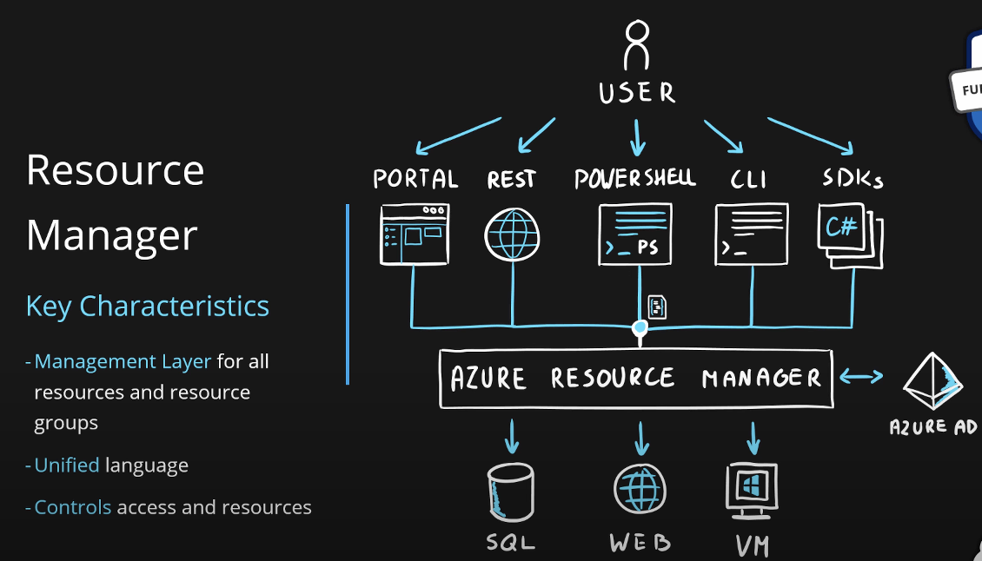

**Additional Info**

* Each **resource must** be in one, and **only one resource group**
* Resource **groups have their own location** assigned
* Resources in the resource groups **can reside in a different locations**
* Resources **can be moved** between the resource groups
* Resource **groups can’t be nested**
* Organize based on your organization needs but consider
  + Billing
  + Security and access management
  + Application Lifecycle